Stratified MAZDASPEED/MPS 3/6 Custom Tuning FORM

Using the COBB AP

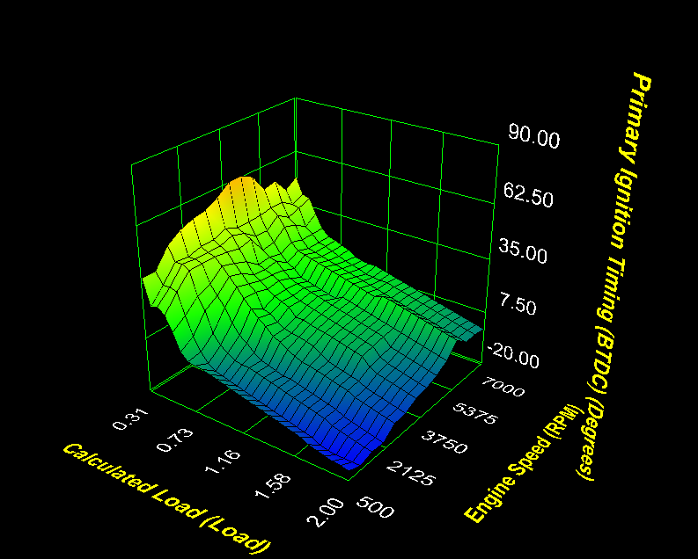

LEGAL STATEMENT – PLEASE READ CAREFULLY

Below is the limited liability statement that governs the relationship between you, the customer, and Stratified Automotive Controls LTD. during the custom calibration process. Please read carefully. Once read and understood, please e-mail the following statement to your Stratified Automotive Controls LTD.

"I understand the risks of tuning and understand that Stratified is not liable for damages, costs, injuries that may be incurred in my working relationship with them."

ALL parts and services are sold for OFF ROAD, RACE-ONLY ground vehicle use only.
Aftermarket calibrations and systems interacting with engine function are not for use on pollution controlled vehicles. Alteration of emission related components constitutes tampering under most local emission regulation guidelines and can lead to fines and penalties.

Stratified Automotive Controls LTD. is not responsible for any fines, injuries, costs, or damages incurred as a result of the tuning process or our relationship with you, the customer. It is the complete responsibility of the customer to ensure their vehicle is operating in a safe and lawful manner, respecting all local laws and regulations.

Stratified Automotive Controls LTD does not offer or imply any warranty or guarantee for the results or outcome of the calibrations sent to the customer during the tuning process.

Stratified Custom Tuning Procedure for the Mazdaspeed/MPS 3/6 Using the COBB AP

Thank you for purchasing the Stratified Custom Tune for your vehicle! The tuning process itself is pretty straight forward and you will get a chance to interact with an experience individual that has worked with these vehicles extensively.
Your tuner will ask for certain datalogs and in turn will be sending you map revisions, and provide coaching along the way to help you achieve your tuning goals. This process will continue until you and your tuner are happy or the tuning time purchased expires. Since there is an expiration period for the tune it is important to have your hardware in order and be prepared to datalog quickly after receiving a new iteration of the tune. Depending on goals and vehicle setup, it usually takes a few iterations to get everything dialled in. During this time, contact your tuner with any questions you may have.
After you have purchased the tune, your tuner will contact you and you will have to complete the form below and send it in along with your current map and datalogs requested before the tuning process begins. The items in the form are described below.
Your Full Name:
Your Contact E-mail for Tuning:
Vehicle Year:
Vehicle Make and Model:
Vehicle Modifications Installed:
Fuel you are currently using:
Tire size currently installed on the vehicle:
AccessPort Serial Number
Tuning Goals:
How did you hear about Stratified?
Why did you choose Stratified for tuning?
I have read and agree to the terms of the Stratified LEGAL STATEMENT and I understand the risks of tuning and understand that Stratified is not liable for damages, costs, injuries that may be incurred in my working relationship with them.
Please attach/include the following datalogs and map file along with this completed document when replying to your tuner
The exact map file you are currently running
A MAF calibration datalog (read below for parameters to log)
A WOT datalog (read below for parameters to log)

Your Vehicle Information:
Your tuner must know what modifications you have installed or of any other special issues with your vehicle. As power increases, OEM (and some aftermarket) hardware will become incapable of keeping up. It's not uncommon to see the CDFP (cam driven high pressure fuel pump) not keep up with increased power and boost. There are aftermarket solutions for most parts that require upgrading.
Make sure all your hardware is in tip- top shape. Tuning around a hardware issue (like an exhaust leak, or a boost / vacuum leak) will only complicate things and result in a much more difficult and costly tuning process.
Also (as I am sure you know this) be aware that the increased loads and stresses due to more power on your motor can negatively impact reliability. We use our extensive experience and common sense to deliver a safe and powerful tune to your liking; but you are the one in the driver's seat and you have the control over the situation and your vehicle.
Please fill in the following data above:
Year:
Model of Vehicle (MazdaSpeed3, MazdaSpeed6, etc.):
Engine and Relevant Modifications (Intake, Boost Control Method, Exhaust, etc.):
The fuel you are using:
**If using E85 blends, it has been shown that a 1/3 mix is effective and mild on your fuel system and pump. When mixing E85, make sure you always mix in the same proportions during every fill-up. For example, if you are adding 3 gallons of E85, add 9 gallons of gasoline. If you are adding 1 gallon of E85, add 3 gallons of gasoline etc.**
Tire size currently installed: This is used to estimate power output using tools such as Virtual Dyno and the size is found on the sidewall of the tire and is written as XXX/YY/RZZ. The stock size for the 2010+ MazdaSpeed3 is 225/40/R18.
AccessPort Serial Number:
On V2 AccessPorts the serial number of your AP is written on the back of the handheld unit and a sample is shown below:
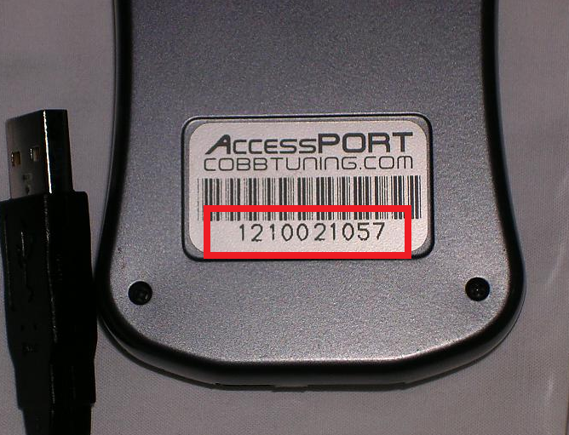
On the V3 AccessPorts the serial is written under the faceplate. The faceplate needs to be removed to see the serial as shown below:
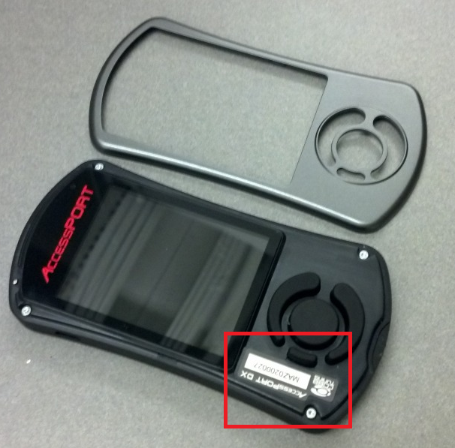

Your Tuning Goals
Let your tuner know what your overall tuning goals are. Let them know if there are particular conditions under which the car will be operating (extreme heat or cold, or being tracked often). This will help the tuner build a tune that caters to your driving environment and needs.

Your Current Tune
If you already have a tune installed on the vehicle and are using this tune to create the initial datalogs, send this (the .ptm file) to your tuner for cross-referencing.

A MAF Calibration Datalog
The mass air flow sensor (MAF) is one of the most important sensors in the car as it tells the ECU how much air the motor is ingesting so that it knows how much fuel to deliver. When using aftermarket intakes, the MAF tables must be adjusted and a MAF calibration log must be done.
1. To do this, the following parameters need to be logged:
RPM
STFT
LTFT
MAF (g/s)
MAF Volts
Closed Loop (2010+s only)
2. Make sure the map you have flashed right now has been on the car for a couple hundred miles.
3. Warm up the car - 15-20 minutes normal driving. Turn off the A/C when starting to log.
4. Display the MAF (g/s) so you can watch this as you're logging.
5. Start in 2nd gear at 1500RPM and slowly accelerate steadily looking at the MAF (g/s) smoothly rising to 100g/s. Go to the next gear and continue applying more boost and throttle trying to smoothly increase MAF (g/s) until you're at 150 g/s. You should be well into boost by this point. Save this log as MAF cal.

A WOT Datalog
If the car is running well and safely, your tuner will need to see how the car responds under WOT conditions.
1. To do this, the following parameters need to be logged. Set you COBB AccessPort to log the correct parameters. If you are unsure how to do this, we have put together a video on our YouTube channel showing this:
http://www.youtube.com/user/StratifiedAuto
Accel. Pedal Pos.
Actual AFR
Boost
Boosted Air Temp
Calculated Load
Coolant Temp
Engine Speed (RPM)
HPFP Actual Pressure
Injector Duty Cycle
Intake Temp
Intake Valve Adv.
Knock Retard
Long Term FT (LTFT)
MAF Voltage
Mass Airflow
Spark Advance
Throttle Position
Vehicle Speed
Wastegate Duty Cycle
2. Make sure the car is warmed up and find a nice long flat safe piece of road to do two 3rd or 4th gear WOT datalogs (4th is generally better since the loads are higher but only do this if the conditions allow). Remember to most importantly be safe!
3. Perform these full gear pulls from 3000 RPM to 6500 RPM. When taking WOT logs don't roll into the throttle slowly. Punch the throttle to the floor as quickly as possible and hold it down for the entire pull.
4. Make sure the car has the gas you usually run in it and plan on running. Keep using this same gas during the entire tuning process and thereafter or let your tuner know otherwise. Gas quality has a high impact on the performance of the car DISI engine.
5. If you run methanol injection for cooling alone, turn it off for these runs.
6. Finally try to do these and future logs on the same stretch of road that is flat. This way the performance of the car can easily be analyzed as you and your tuner adjust the tune.

The legal disclaimer
Please read the first page of this document and check the box in the form if you agree to the disclaimer. This is required in order for your tuner to start sending you new maps/calibrations.
This should get you started. Your tuner will analyze the data you sent and get back with the first map or questions/issues if anything stands out.
Thank you,
The Stratified Team

